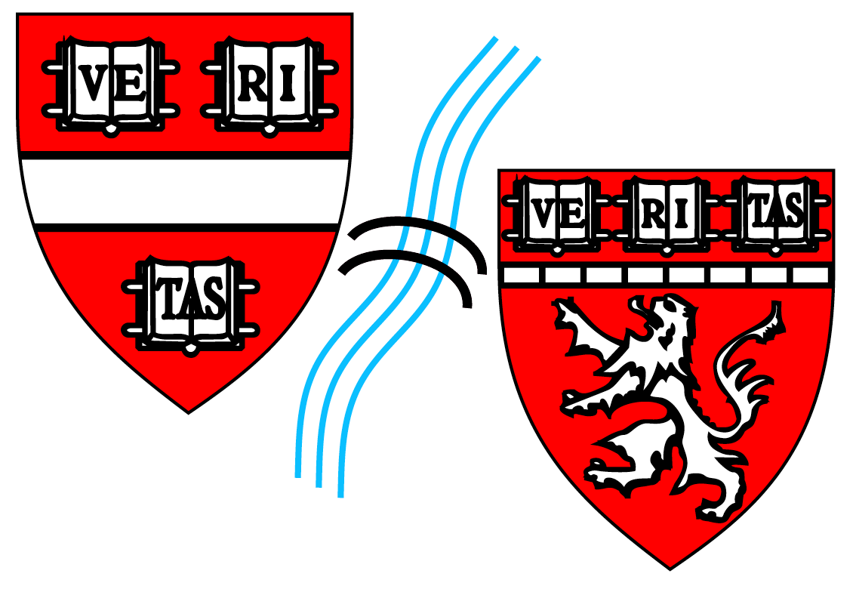
STUDENT END-OF-INTERNSHIP
REPORTING FORM
HARVARD BIOPHYSICS
Graduate Program

Student  Name: |  |  | Organization Name:
Dates of Internship: |  |  | Organization Address:
Internship Mentor/ Supervisor: |  |  | Internship Supervisor  Contact Information: | Email:  Phone:

Please Complete the Following Questions on Completion of Your Internship Experience:

What were your overall goals in carrying out this internship?
What were your technical goals for this internship experience?
What were your professional development goals for this internship experience?
What were your clinically relevant goals for this internship experience (if applicable)?
Please describe the mentoring you received during the internship:
Please describe when and how you received feedback:
What did you accomplish during this internship?
How did your accomplishments during your internship contribute to the organization?
Did you contribute to any intellectual property with the organization?
Describe any areas in which you did not achieve the desired outcome(s) and why not:
How has your internship impacted your plans for the remainder of your graduate student career, and your future career plans?
Graduate Student: | Signature: | Date:
Return Form To: Michele R. Eva (Michele_jakoulov@hms.harvard.edu)
Harvard Biophysics Graduate Program
Seeley G. Mudd Bldg., Room 204c, 250 Longwood Ave., Boston, MA 02115
617-432-3802

