Rachelle Gaudet, Ph.D., Co-Chair 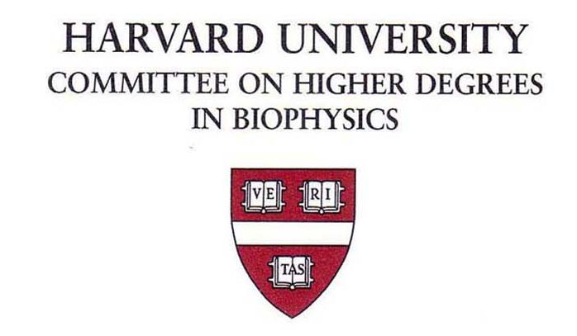 Harvard Medical School
Martha L. Bulyk, Ph.D., Co-Chair Seeley G. Mudd Bldg. Room 204c
Michele R. Eva, Administrator 250 Longwood Avenue
Tel: (617) 495-3360
Or: (617) 432-3802

Dissertation Advisor Declaration Form

This form verifies the mutual agreement between the Biophysics Student indicated and Faculty Member taking on the role of Dissertation Advisor for this student’s graduate training through the degree.

It outlines the roles and expectations (mentoring, financial support, etc.) in the different stages of a student’s training trajectory and G Year.

Date:

Biophysics Student:

Student’s Current G Year:

Faculty Member(s):

Student Requirements (G1 & G2 Years):
Students in the first two years of their PhD studies in Biophysics are required to complete a number of Program requirements, including:
- Two required core courses: 1st Year Fall semester Biophysics 300: Introduction to Laboratory Research (rotation and critical literature reading) course, and 1st year Spring semester Biophysics 242
- 2nd Year Fall semester Biophysics 3001qc: Research Design and Proposal Writing Quarter Course.
- Completion of 5 full-semester elective Courses, at least 4 of which must be taken on a letter-graded basis.
- Completion of the DMS MedSci 300qc: Responsible Conduct of Science course (Fall semester, 2nd year).
- At least 3 Laboratory Rotations of approximately 8-10 weeks each, leading toward the declaration of a dissertation research lab.
- One semester of Teaching in a course that provides experience in presenting lecture materials, running sections and office hours (within the 2nd year).
- Development, presentation and defense of an “off-topic” research proposal at the Preliminary Qualifying Exam (PQE; to be completed and defended before March 31st of their 2nd year).
- Annual Individual Development Plan (IDP) Survey and IDP mentor meetings.

Faculty: I understand and agree to allow the Student Advisee the time required to complete the above Program Requirements:

Student: I understand and agree to complete the Program Requirements for the first two years in as timely a manner as possible. I also agree to maintain clear communication with both my research advisor and Program Administration regarding any circumstances or delays that might impact the completion of these requirements and attention to beginning full-time research work.

Student Requirements (G3 Year through Degree):
- Dissertation Advisory Committee (DAC) Meetings. Within 6 months of the successful completion of the PQE, students should set up and convene a meeting of their DAC. Faculty advisors are required to attend such DAC meetings, but do not serve as committee members. Subsequent meetings should take place on a yearly basis, or more frequently, based on the recommendations of the DAC.
- Research Manuscripts. Preparing (and ideally submitting) research manuscripts for peer review is an important part of a graduate student’s training.
- Research Presentations at internal graduate program events such as poster sessions, retreat talks, and graduate student research dinner talks.
- Annual Individual Development Plan (IDP) Survey and IDP mentor meetings.
- Completion of the DMS MedSci 302qc: Responsible Conduct of Science refresher course (Fall semester, 6th year).
- Dissertation Defense and Graduation. Based on the determination by the student’s DAC that the student has completed enough to write up and defend their dissertation research. Faculty advisors are required to attend the student advisee’s defense, but do not serve as dissertation defense committee members.

See https://biophysics.fas.harvard.edu/academics for more information.

Faculty: I understand and agree to supporting the development of my Student Advisee as an independent scientist through their fulfillment of the above requirements, including setting aside time for meetings, mentoring and advising:

Student: I understand and agree to maintain satisfactory progress to the best of my ability, the timely fulfillment of program requirements and the appropriate application of time and energy toward research work in fulfillment of the PhD Degree.

Financial Support (Note that Research Assistant rates for the 2025-26 year are not yet determined):
G1 & G2 Years:
In the initial two years in the Biophysics Program, the Student is supported at the standard stipend rate set at the time (rates negotiated with the HGSU) –the current 2025-26 stipend rate is $50,460/yr, and the “Full” tuition and health insurance fees –current 2025-26 rates are set at $63,436/yr, paid by program funds or other individual fellowships.

G3 & G4 Years:
As of July 1st of the year that the Student enters their 3rd G-Year, Faculty Advisors are required to assume financial support responsibility at the standard stipend rate set at the time (rates negotiated with the HGSU), and the “Reduced” tuition and health insurance fees –current 2025-26 tuition rates are set at $21,012/yr.

G5 Year and Above:
As of July 1st of the year that the Student enters their 5th G-Year (and future G-Years), Faculty Advisors are required to assume financial support responsibility at the standard stipend rate set at the time (rates negotiated with the HGSU), and the “Facilities Fee” tuition and health insurance fees –current 2025-26 tuition rates are set at $9,900/yr.

All G Years:
Students who apply for and receive internal (Landry, Merit, GPF) or external (NSF, NRSA, NDSEG, etc.) fellowship support, are required to be supplemented up to the standard stipend and tuition and health insurance rates in effect for the fiscal year by their faculty advisors.

In late March or early April each year, the Biophysics Program Administrator sends a letter indicating the specific details of a student’s support requirements, including updated stipend, tuition and health insurance rates for the upcoming fiscal year, beginning July 1st. At this time, the details of how a student’s support for the fiscal year ahead is to be processed are determined.

Faculty: I understand and agree to the student financial support requirements for the Student Advisee indicated and understand that specific details regarding such required support will be communicated during the Spring semester for the fiscal year beginning July 1st each year:

Student: I understand and agree that the guarantee of financial support is contingent on my maintaining satisfactory progress, the timely fulfillment of program requirements and appropriate research efforts toward the PhD degree.

The Mentoring Role
The Biophysics Program is committed to promoting a safe, supportive, and dynamic environment for the education and training of our students in a non-discriminatory manner. We expect that faculty engaged in advising students within the program share this commitment and take on the mentoring role as the important and serious responsibility that it is.

As part of this responsibility, we expect that faculty advisors will:
- Meet regularly with students to discuss their scientific research goals and progress in the laboratory.
- Support students in fulfilling their program requirements.
- Provide students with access to resources to further their scientific and professional development goals.
- Conduct yearly Individual Development Plan (IDP) meetings with students, including conversations about career and long-term goals and options (IDP Survey forms and reports provided by the Biophysics Program).

We require faculty advisors to have completed CIMER-based (or comparable) mentor training (details below), or to complete such training within one year of program faculty affiliation and/or serving as a research advisor.

Please provide us with the most recent training completion dates, or your plan for completing the training, for our records:

Note that Mentor Training is expected for all HILS faculty members, and it is a requirement for all NIH T32 training faculty. HILS has a special CIMER-based course in the Harvard training portal, and they track faculty that have met the CIMER (or comparable) Mentor Training workshop requirement. The upcoming CIMER-based training offerings dates and times can be found in the following link: https://cfme.hms.harvard.edu/workshops

Comparable training: HILS (and we) ask that faculty have completed at least 6 hours of mentoring training for it to be considered comparable to the HILS-sponsored CIMER-based training. If you have completed another comparable Mentor Training workshop, please submit the information on that training to hils@fas.harvard.edu and the Biophysics Program Administrator, including the date of the training, topics and competencies covered, and number of hours of instruction, for your completion to be registered in their records. The most commonly accepted comparable training is faculty mentor training for the HHMI Gilliam fellows.

We encourage faculty advisors to engage in offered training for:
- Title IX concerns.
- Understanding Bias.

Non-academic Lab Duties: The Harvard Graduate Student Union contract restricts the number of hours students can be asked to work on laboratory duties separate from their academic research to no more than 20 hours per week averaged over the year.

We suggest that faculty advisors and students joining laboratories create a compact at the outset of that relationship, laying out expectations for time, any lab-related duties, understandings on publication authorship related to students’ research, etc.

Faculty: I have read and agree to the above Mentoring Role expectations.

Student: I understand and agree to the expectations in my role as Mentee.

Student Signature:
____________________________________

Faculty Advisor Signature:
_____________________________________

