Rachelle Gaudet, Ph.D., Co-Chair 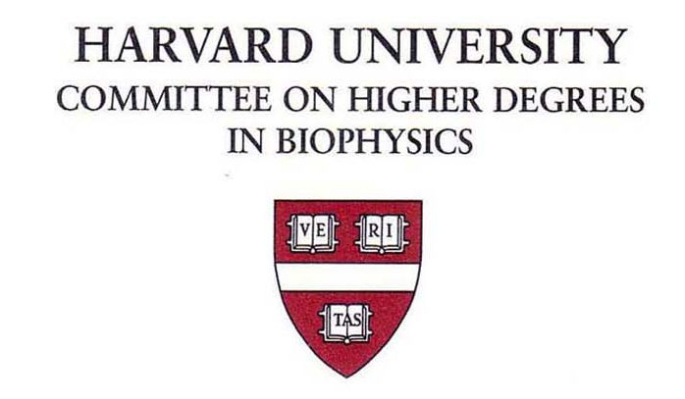 Harvard Medical School
Martha L. Bulyk, Ph.D., Co-Chair Seeley G. Mudd Bldg. Room 204c
Michele R. Eva, Administrator 240 Longwood Avenue
Tel: (617) 495-3360
Or: (617) 432-3802
Date:

To:

From: Michele R. Eva

Rotation Evaluation
The Biophysics student whose name is listed below has undertaken a rotation period in your laboratory. Please provide an evaluation of the student’s performance and a grade recommendation so that we may submit a grade for the semester to the GSAS Registrar’s office in time for their deadlines. Please return this form as soon as possible, but no later than:
____________________ by reply email to: michele_jakoulov@hms.harvard.edu

Student:

Rotation Start Date: _________________ End Date: ____________________

Excellent Average Poor

Technical skills _______ _______ _______

Lab attendance ______ _______ _______

Communication skills ______ _______ _______

Knowledge of subject ______ _______ _______

Overall Grade Recommendation: SATISFACTORY______ UNSATISFACTORY_______

Would you consider accepting this student into your laboratory for dissertation work?

YES____________ NO__________ (if no, please state why not)

Please provide brief feedback that will be shared with the student, commenting on the skills learned and the progress made during this rotation, the student’s strengths and weaknesses, any gaps in knowledge and any recommendations for further training:

If you have any additional comments for the program leadership (not to be shared with the student), please include below:

