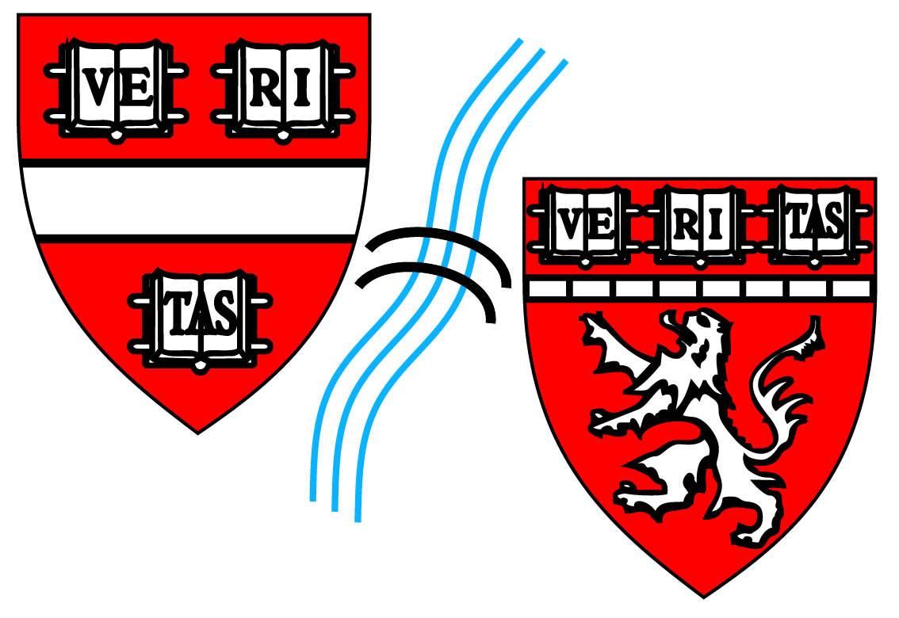 HARVARD BIOPHYSICS INDIVIDUAL DEVELOPMENT PLAN (IDP)
Student Name:

Advisor Name:

G Year:

Date:
Survey Form (for Students in All G Years)

Complete this form in September and share relevant, as well as desired, portions with your Biophysics Program advisor and/ or, for G2 Students and above, with your dissertation mentor or an alternate faculty member of your choosing (approved by the Program), prior to and in preparation for your planning meeting in the beginning of the Fall semester. This IDP is designed to help you think about your goals for the year and provide a useful foundation for maximizing the productivity of discussions with, and mentorship by, your Biophysics Program advisor(s), and solidify your plans for the coming year.

The Survey contains three main sections: Main Questions, Skills Assessment, and Action Plan.
Questions highlighted in Yellow are those required to be submitted to Biophysics Program. Those in Orange are those we would hope to have shared with us in order to better advise you on steps to take to reach your goals. Those in Green are optional to share, but that we hope you will think about candidly and answer for their value in helping you clarify the best path ahead, as well as to use for discussion points as part of your yearly training/ career-planning meeting (see IDP information sheet).

We also encourage students to visit http://myidp.sciencecareers.org where additional IDP resources are provided as well as excellent articles related to mentorship and science careers.

MAIN QUESTIONS
Students in all G Years:

What Biophysics Program Requirements have you completed thus far? Include Fall & Spring G1 and G2 Courses (as applicable):
Courses:

Biophysics 242r: Biophysics 300:
MedSci 300qc (ethics): MedSci 302qc (ethics refresh):
Teaching: PQE:
1st DAC Mtg: Add’t DAC Mtgs: ABD (All But Defense):

What Biophysics Program Requirements will you complete this year?

What are the remaining Biophysics Program Requirements to satisfy and do you have a clear sense of what you need to do/ how to fulfill those requirements?

What are your academic/ professional goals for the coming year?

What resources or support mechanisms do you plan on using to help you accomplish these goals? (e.g. Faculty Mentor, the Biophysics Program office, Harvard Office of Career Services, Harvard Bureau of Study Counsel, Other…)

Could other resources be provided that would be helpful? (Please discuss this with your Faculty Mentor, the Biophysics Program office, your Program Advisor and/or Program Head, if so and as you feel comfortable, as this feedback can be used to improve the experience for all students).

Do you have any concerns about the upcoming year of graduate school and beyond? What would help to alleviate these concerns?

Do you feel you understand the difference between short-term stress vs. long-term stress? Do you feel satisfied with your ability to handle either, or is this an area for which you would like to have some guidance and feedback?

How do you approach juggling multiple demands such as deadlines, pressures to produce data, personal/ family needs, etc? Have you found ways to manage your time in an effective way in the face of these various demands?

Do you feel able to objectively and honestly judge where you are in terms of your progress versus where you believe your classmates and peers are in terms of their progress? (Remember that everyone’s research is different, and everyone has entered graduate school with different strengths and weaknesses, as well as levels of experience to begin with).

Do you feel you have established a manageable work/ life balance? Do you have activities and relationships outside of your studies and research that contribute to your well-being? Do you feel you focus enough time and attention on your studies and research to develop into an independent scientist? Could there be adjustments that you could make in either of these areas?

Do you feel you understand the difference between short-term success vs. long-term success? Do you have support systems in place to sustain you during the times when progress and success may not be evident, or immediate?

For G1 & G2 Students:

What qualities are you looking for in a potential dissertation advisor/ mentor? Have you found these qualities in any of your rotations thus far?

What qualities are you looking for in a dissertation laboratory (size, other students, specific research topics, expertise in specific techniques…)? Have you found these qualities in any of your rotations thus far?

Do you plan on applying for fellowships this year? If so, what are the deadlines? Have you thought about whom you will ask for recommendation letters?

For G2 Students (and any G3 Student who has not yet completed this requirement):

How are your preparations for the PQE progressing? Have you identified a proposal topic? Have you identified individuals who can help provide feedback on your idea? If not, who might these individuals be?

For G2, G3, and G4 Students:

How will you prepare for meetings with your Dissertation Advisor this year to make them as productive as possible? Is the current frequency of meetings sufficient? If not, what frequency would be optimal?

What are the goals of your dissertation project? Do you feel comfortable with your knowledge of the relevant literature?

What resources or technical support will you take advantage of to achieve your research goals?

Could other resources be provided that would be helpful?

For G3, G4, G5 and Above Students:

What are the different career paths open to PhD scientists? Which ones appeal to you? What career resources do you plan on taking advantage of in the coming year (e.g. Office of Career Services, Networking Events…)?

What are your long-term professional career goals? What are the most important elements you would want or require in a future career?

What actions will you take this year to support your specific career ambitions?

What resources or support mechanisms do you plan on using to help you accomplish these professional aspirations? (e.g. Harvard Office of Career Services, Harvard Bureau of Study Counsel, Other…)?

What help can your mentor or other faculty provide toward these aspirations?

SKILLS ASSESSMENT (All G Years)
Rate your current skill level on a scale from 1 (weakest) to 5 (strongest)

Research and Science:  Broad-based knowledge of Physics/ Math  Broad-based knowledge of Biology  Quantitative/ Statistical methods  Programming skills  Critical reading of literature  Experimental design  Ability to frame scientific questions  Ability to solve technical problems  Identifying advisors and seeking advice  Time management | Communication:  Writing for proposals or publications  Public speaking  Communicating one-on-one  Giving constructive criticism  Accepting constructive criticism  Networking

ACTION PLAN (All G Years)

What skills will you work on improving this year that are important to your development? What is your plan for improving these skills?

What activities/ resources have you identified that will help you achieve your academic objectives this year? (Be sure to ask your program advisor about additional resources)

Given potential fellowship deadlines (if applicable), when will you start putting the application together? Plan to start early enough so that you can receive feedback from your colleagues on the initial draft of your proposal.

If applicable, compare your current skills assessment to your previous IDP. Have you successfully addressed areas of emphasis from the previous year? If not, what will you do differently this year to improve these areas?

What new skills are you designating as important for developing during the coming academic year? What is your plan for improving these skills?

What activities/ resources will you take advantage of to help you achieve your academic and research objectives this year?

NOTES/ ADDITIONAL THOUGHTS:

