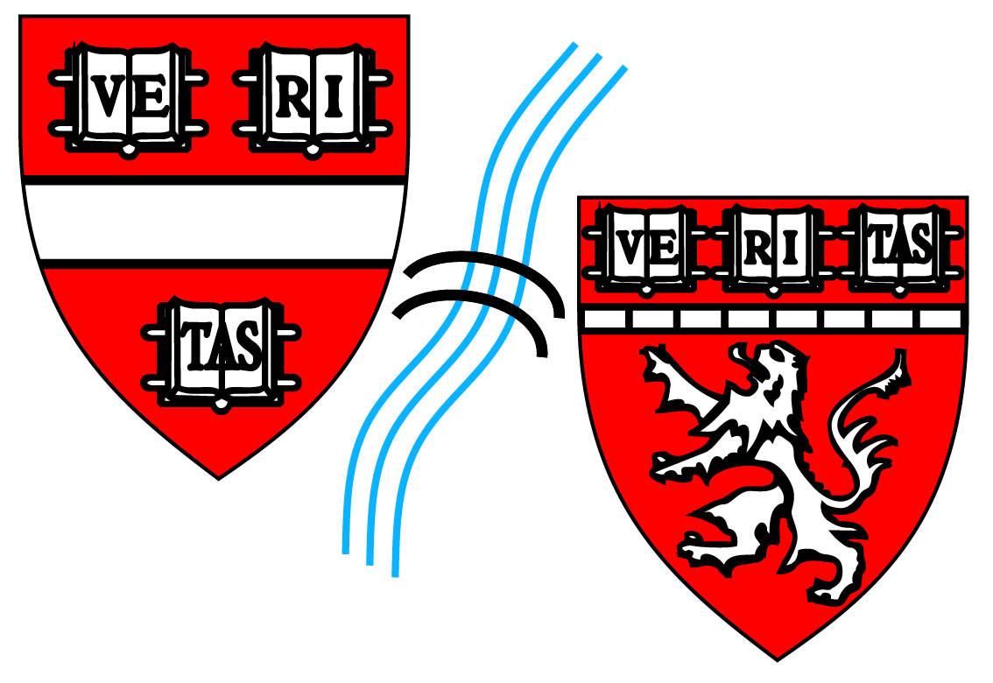 HARVARD BIOPHYSICS PROGRAM

Request for Consideration as a Member of Affiliated Biophysics Faculty
Thank you for your interest in becoming one of the affiliated faculty members in the Biophysics PhD Program. The Program is an interdisciplinary PhD granting committee, whose membership is determined by a vote from members of the Faculty Standing Committee on Higher Degree in Biophysics.

To assist the Committee with making a determination of appropriateness for inclusion, please send along the following items via email, along with this form, filled out, to Michele_jakoulov@hms.harvard.edu or james_hogle@hms.harvard.edu Please let us know if you have any questions.

- Current Biosketch or CV

- One page Research Description

As a non-departmentally-based interdisciplinary program, Biophysics relies on the voluntary participation of its faculty members for the maintenance of procedural cohesion and to help form the core character of the Biophysics community as a whole. The commitment to training and mentorship of students within the Program is an integral criteria for membership in the group of Biophysics Affiliated Faculty, and along those lines, we ask that you indicate the areas in which you would be willing to participate in the sections below.

Faculty Member Name:

Participation in Biophysics 300 Introduction to Laboratory Research (Rotation) Course:
Participation in Teaching Other Specific Program Courses (ie: Biophysics 242r: Special Topics in
Biophysics):

Serving as Examiners on Student Preliminary Qualifying (PQE) Exams:
Serving as Advisors on Student Dissertation Advisory (DAC) Committees:

Attending Annual Biophysics Program Retreat: | Attending Annual Recruitment Visit Weekend Faculty/ Student Dinner:
Attending/ Presenting Posters for Retreat Poster Session: | Attending/ Presenting Posters for Annual Recruitment Visit Weekend Poster Session:

Presenting Talks for Retreat Talk Sessions: | Presenting Talks for Annual Recruitment Visit Weekend Mini-Symposium:
Attending Student Dinner Talks and/ or Visiting Researcher Seminars:
Attending Other Program Sponsored Events (ie: Kick-Off BBQ, End-of-Year Clambake )
Accepting Rotation Students from the Biophysics Program:
Accepting Dissertation Advisor Role for Students in the Biophysics Program:
Understanding and Agreeing to the Mentoring and Financial Support Requirements for Students for Whom
You Might Serve as Dissertation Advisor:
Current # of Graduate Students/ Postdocs You are Mentoring:

