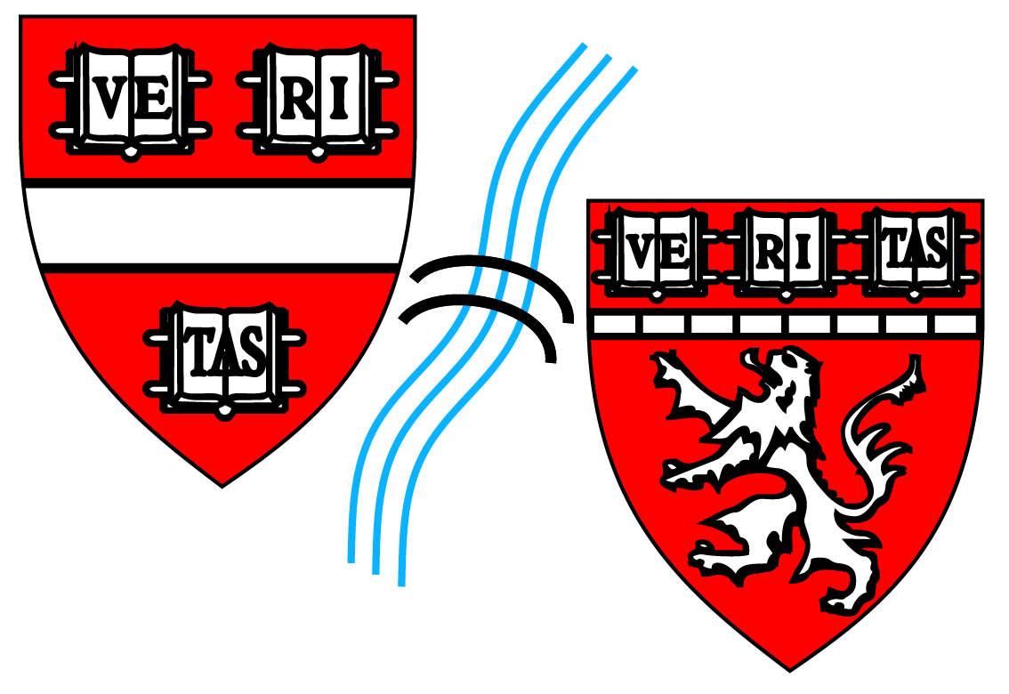 HARVARD BIOPHYSICS PROGRAM

Mission Statement:

Biophysics applies the theories and methods of physics to understand how biological systems work. The Biophysics Program at Harvard University aims to train graduate students focused at the interface of physical and biological sciences.

The Biophysics Graduate Program seeks to attract students who have strong undergraduate backgrounds in quantitative sciences (especially physics and mathematics) and who are interested in a deep dive into biological and biomedical research. The program provides broad training in the biophysical, chemical and molecular concepts and techniques that are required to address outstanding problems in biology and biomedical sciences. This interdisciplinary graduate program offers training in approaches to explore the structure, function and interactions of key macromolecules of the cell, the control of cellular and multicellular processes at the molecular and genome-wide levels, as well as the development of methods to image and model these processes. The Program comprises a community of faculty and their labs, providing opportunities for collaborative research and training opportunities. Students apply their training to research areas such as studying macromolecular structure or folding, developing new imaging or measurement tools, or to building models that explain how biological systems transform energy, matter, or information. Some trainees will also learn to use this information to diagnose, understand, prevent or cure human diseases.

In a field as diverse as Biophysics, it is impossible to represent every area of research. Historically, the Harvard Biophysics Program has had unusual strengths in areas of mechanistic biology where physical principles are paramount (e.g., structural biology and cellular dynamics) and in development of new physical measurement tools (e.g., single-molecule methods and imaging techniques). These areas of research will remain foundational, but future progress in the life sciences will crucially depend on continued identification and support of developing areas of research. These research areas will emphasize a fundamental physical science approach not just in terms of tools and techniques, but also in the mode of explanation of biological phenomena.

Given the small size of the Graduate Program student body, and the desire to differentiate it from the many other excellent Graduate Programs at Harvard, Faculty mentors will be carefully chosen to fulfill the overall mission of the Graduate Program. There will be two levels of affiliation, with different expectations and exposure to students through invitations to recruitment, student activities, and student community events, depending on level of effort as affiliated faculty member. Appointment to the Program as a Core faculty member will be restricted in order to sharpen the focus of the Program, which will also fulfill the requirements of the NIH Training Grant, which encourages a core group of dedicated faculty mentors. Appointment as a Core faculty member will reflect faculty contributions to the educational mission of the program and active participation in student training events. Diversity of mentors, in terms of research topics, career stage and demographics, will also be a strong guiding principle. Additional faculty will be appointed to the Program as Affiliates, who participate in the Program and whose research falls within the broad field of Biophysics.
___________________________

Affiliation with the Biophysics Program is decided by the Standing Committee on Biophysics, is iimited to those in tenure-track faculty positions, is based on demonstrated commitment to the training and mentoring of students; participation in program-based student academic milestones and community events; and the relevance of research focus to the core definition of biophysics and the mission of the Biophysics Program. Faculty affiliation will be reviewed every 3 years.

I wish to be affiliated with the Biophysics Program:
Yes
If you wish to be affiliated with the Biophysics Program, please complete the questions below.
2022/ 2023 Application for Affiliation as Biophysics Faculty

Please send this completed form along with your current Biosketch or CV and completed Research Advisor Expectations form via email to michele_jakoulov@hms.harvard.edu (please include “Affiliation” in the subject line).

A. Your Information
Name:
Harvard title: Department:
Mailing address:
Office phone: Fax (if available):
Email:
Administrative assistant: Assistant Phone:
Administrative assistant email:
Financial/billing contact:
Date of first appointment as Harvard Tenure-track Faculty:
Lab website URL:
B. Student Training Experience
Number of Harvard PhD graduate students (from any program) in lab currently:
Number of postdocs in lab currently:
Total laboratory size (including PI) currently:
Number of graduate students (from any program) and postdocs who completed training in the lab in the past 5 years:
Average Number of Committees you serve on per year (+ specify whether for Biophysics vs. other programs):
Preliminary Qualifying Exam (PQE):

Dissertation Advisory Committee (DAC):

Dissertation Defense Committee:

Graduate Admissions Committee (include years served):

C. Courses & Program Activities
(we understand that for newer faculty members, questions on past participation may not be relevant)
Participation in Biophysics 300 (Introduction to Laboratory Research) Course in past 5 years:
Participation in teaching other Program-specific courses (e.g. Biophysics 242r) in past 5 years:
Participation in MED SCI 300qc/ 302qc (Conduct of Science/ ethics) in past 5 years:
List other courses you have participated in teaching in the last 5 years:
List the number of times you have attended the following events in the past 5 years:
Annual Biophysics Program retreat:
Annual Biophysics Mini-Symposium (part of recruitment weekend):
Annual recruitment visit faculty/student dinner:
Poster Session as part of recruitment weekend:
Student dinner talks and/ or visiting researcher seminars:
Program-sponsored social events (ie: Kick-Off BBQ, End-of-Year Clambake):
Do you anticipate generally accepting rotation students from the Biophysics Program in each of the next 3 years?
Yes No
Will you accept being a dissertation advisor for students in the Biophysics Program, pending an acceptable rotation?
Yes No
Will you agree to the mentoring and financial support requirements for students for whom you might serve as dissertation advisor?
Yes No
Will you agree to participate as an Individual Development Plan (IDP) mentor for students?
Yes No
Are you willing to participate in recruiting students, including interviewing them and following up?
Yes No
Are you willing to participate in PQE, advising, dissertation defense, and admissions committees?
Yes No
Are you willing to participate in Biophysics events such as the annual retreat with talks or posters?
Yes No
Will you encourage Biophysics students in your lab to participate in the annual Biophysics Program retreat?
Yes No
Will you encourage Biophysics students in your lab to present posters and talks in program events?
Yes No
Would you be willing to participate in the GSAS Faculty Diversity Ambassador Program on behalf of the Biophysics Program? As part of the Faculty Diversity Ambassador Program, in conjunction with travel to give traditional departmental seminars, interested faculty attend an additional meeting with students from underrepresented backgrounds and/or directors of programs for URM students at the institution or at a nearby minority serving institution. Coordination of meetings and materials are provided by GSAS.
Yes No
If you had to choose, please indicate your top priorities and what you would consider your most important commitments from the list above:

D. Mentoring and Support Expectations of Affiliated Faculty/ Research Advisors
The attached Research Advisor Expectations document lays out important considerations for faculty taking on the research advisor role. Please read and indicate your understanding and agreement on each section of the research advisor expections and return with the Faculty Affiliation Request form.
We require all faculty who might serve in the role of mentor/ research advisor to have completed a Mentor Training course, either through CIMER, or other approved Mentor Training, by July 2023.
Please provide date of most recent Mentor/ CIMER Training within the prior 4 years (if applicable):

Describe your research interests (250 words or less)

Please indicate how your research, potential mentorship of graduate students, and affiliation with the Biophysics Program will further the goals of the program. (100 words or less):

