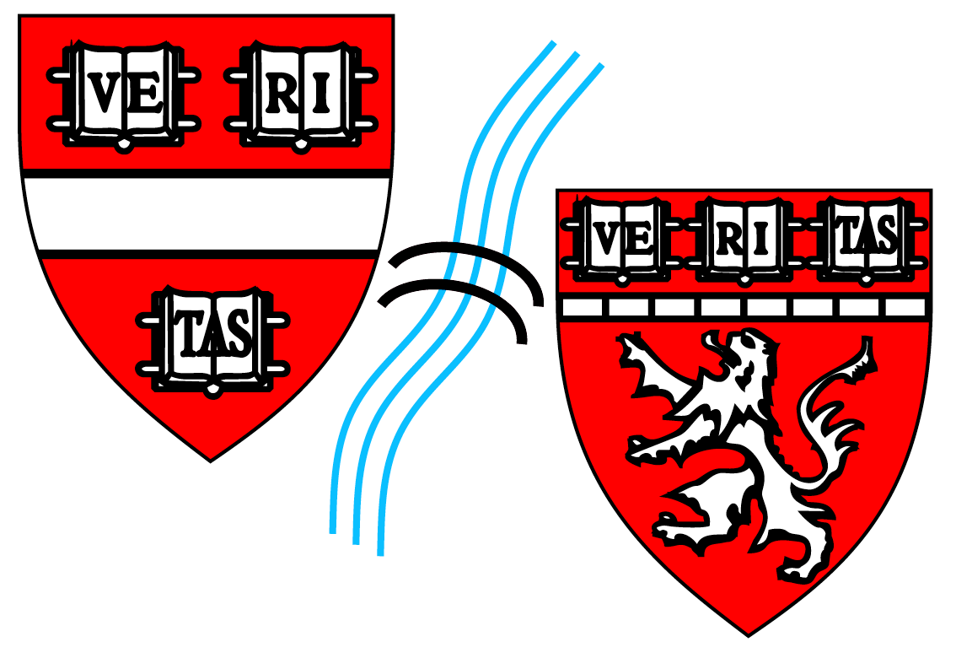
INTERNSHIP APPROVAL FORM
HARVARD BIOPHYSICS
Graduate Program

Student  Name: |  |  | Dates of Internship:
HUID: |  |  | Organization Name:
Grad Year: |  |  | Organization Address:
Date of Most Recent DAC Meeting: |  |  | Internship Supervisor:
Expected Date of Next DAC Meeting: |  |  | Supervisor  Contact Information: | Email:  Phone:
Anticipated Graduation Date:

Please Include the Following Documents When Submitting this Application Form:
- An invitation letter from the sponsoring organization showing a depiction of the intended internship, length of internship, and salary.
- A description of the type of work and objectives of the internship.
- An agreement from the sponsoring organization explaining your compensation package (if applicable).
- International students only: Curricular Practical Training (CPT) Form.

Dissertation Advisor: | Signature: | Date:
DAC Committee Chair: | Signature: | Date:
Graduate Student: | Signature: | Date:
Program Co-Chair or Designee: | Signature: | Date:
Return Form To: Michele R. Eva (Michele_jakoulov@hms.harvard.edu)
Harvard Biophysics Graduate Program
Seeley G. Mudd Bldg., Room 204c, 250 Longwood Ave., Boston, MA 02115
617-432-3802

